DA Lab 2
Analysis of IPL-2019 Dataset

Name: Dheeraj Chaudhary

Roll: 17BCS009

library(tabulizer)
library(dplyr)
library(ggplot2)
library(reshape2)
library(magrittr)
library(tidyr)

######################### READING MATCHES CSV FILE #######################
matches <- read.csv("/home/dheeraj/Desktop/Lecture/6th_sem_Academics/DataScience/Lab2/matches.csv", stringsAsFactors = FALSE)
data <- read.csv("/home/dheeraj/Desktop/Lecture/6th_sem_Academics/DataScience/Lab2/deliveries.csv", stringsAsFactors = FALSE)
matches <- matches[,-18]
data$wickets <- as.numeric(ifelse(data$player_dismissed =="" ,"",1))

######## Number of matches in the dataset (We can see 60 matches were played in IPL’2019)
summarize(matches,no_of_matches = n())
##### OUTPUT > no_of_matches 60

######### Which Team won by maximum runs? (We can see SRH won y 118 runs)
max_run <- matches[which.max(matches$win_by_runs),]
select(max_run, winner, win_by_runs)
###### Output > winner win_by_runs
11 Sunrisers Hyderabad 118

######### Which Team won by maximum wickets? (We ca see SRH won by 9 wickets)
max_run <- matches[which.max(matches$win_by_wickets),]
select(max_run, winner, win_by_wickets)
###### Output > winner win_by_wickets
38 Sunrisers Hyderabad 9

########################### Teams and matches won (We can see MI wo maximum matches)
matches%>%
group_by(winner)%>%
summarize(most_win = n())%>%
ggplot(aes(x = winner,y = most_win,fill = winner))+
geom_bar(stat = "identity")+
coord_flip()+
scale_y_continuous("Matches won")

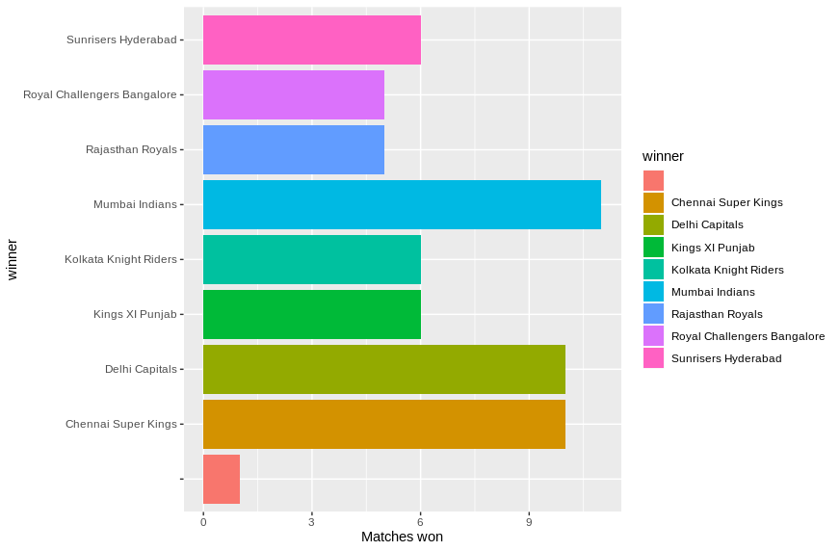
teams <- data %>% select(batting_team)%>%
distinct()
teams <- rename(teams, team = batting_team)
teams
###### Output > team (following teams played in IPL 2019)
1 Royal Challengers Bangalore
2 Chennai Super Kings
3 Sunrisers Hyderabad
4 Kolkata Knight Riders
5 Delhi Capitals
6 Mumbai Indians
7 Kings XI Punjab
8 Rajasthan Royals

s_team <- c("RCB","CSK","SRH","KKR","DC","MI","KXIP","RR")
s_team
##### OUTPUT > [1] "RCB" "CSK" "SRH" "KKR" "DC" "MI" "KXIP" "RR"

teams <- cbind(teams, s_team)
player_of_match <- matches%>% select(id,player_of_match,season) %>%
distinct()
player_of_match <- rename(player_of_match, player=player_of_match)
matches$city <- as.character(matches$city)
matches$city[matches$city==""] <- "Dubai"
venue_city <- matches %>%
select(city)%>%
distinct()

############### Dissmissal type and number of dismissal############################
dismissal <- data%>%
left_join(matches, by=c("match_id"="id"))%>%
left_join(teams,by=c("batting_team"="team"))%>%
filter(dismissal_kind!="")%>%
group_by(season,dismissal_kind,s_team)%>%
summarize(wickets =n())
ggplot(dismissal,aes(x=dismissal_kind,y=wickets,colour=as.factor(season), fill=as.factor(season)))+
geom_bar(position = "stack", show.legend = TRUE, width =.6,stat="identity")+
theme(legend.position="bottom")+
coord_flip()+
theme(legend.direction = "horizontal") +
scale_y_continuous(name="wickets")+
scale_x_discrete(name="dismissal kind")+
ggtitle("Breakdown of dismissal type ")

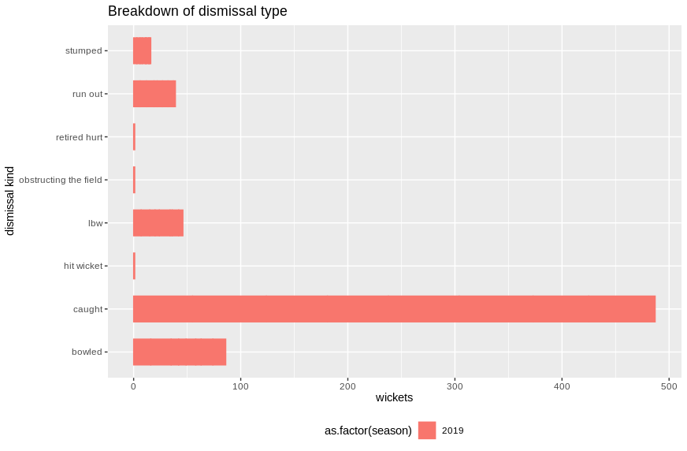
(We ca see in above plot that maximum dismissal was happened due to caught)

######################## Run scored in 1s to 7s #####################
runs_cat <- data %>%
left_join(matches,by=c("match_id"="id"))%>%
left_join(teams,by=c("batting_team"="team"))%>%
group_by(s_team,batsman_runs)%>%
summarize(no=n(),runs=sum(total_runs))

runs_cat$batsman_runs <- as.factor(runs_cat$batsman_runs)

ggplot(runs_cat,aes(x=s_team,y=runs,colour=batsman_runs,fill=batsman_runs))+
geom_bar(position = "stack", show.legend = TRUE, width =.6,stat="identity")+
theme(legend.position="bottom")+
theme(legend.direction = "horizontal") +
scale_y_continuous(name="Runs")+
scale_x_discrete(name="Teams")+
ggtitle("Total runs scored in 1s to 7s")
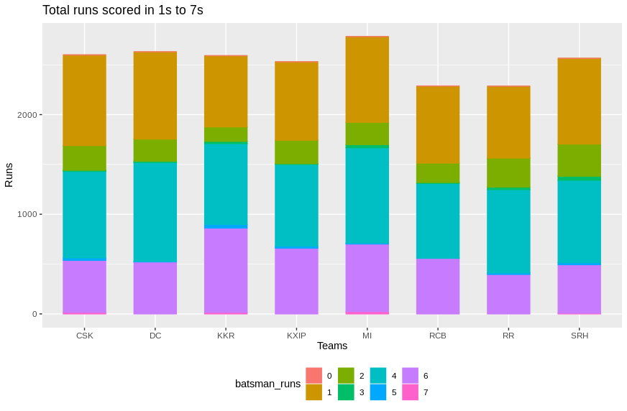

(We ca see in above plot that most of the runs were scored in 1st, 3rd and 6th ball)

##################### toss decision of toss winner ######################
wins_1 <- matches%>%
left_join(teams,by=c("toss_winner"="team") )%>%
select(s_team,toss_winner,toss_decision)%>%
group_by(s_team,toss_decision)%>%
summarize(wins=n())

ggplot(wins_1,aes(x=s_team,y=wins,colour=toss_decision,fill=toss_decision))+
geom_bar(position = "dodge",stat = "identity")+
theme(legend.position="right")+
scale_y_continuous(name="Toss decision")+
scale_x_discrete(name="Toss winners and toss decisions")+
ggtitle("Toss decisions by each Team")
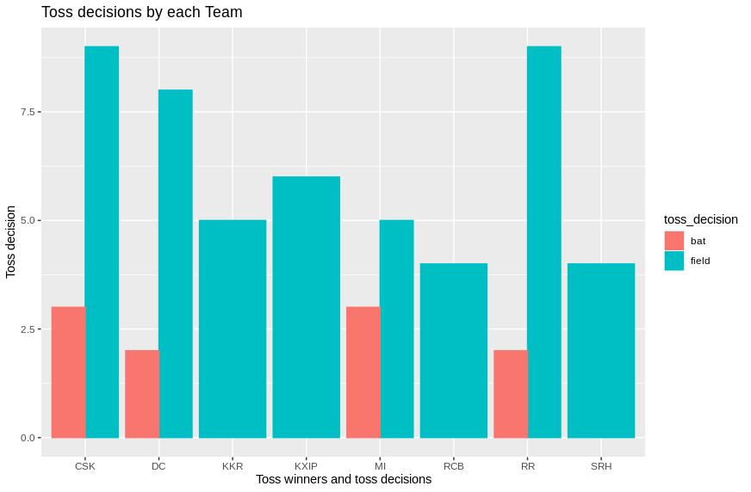
(We can see that CSK and RR choosen fielding after winning the toss and KKR, KXIP, SRH never batted first after winning the toss)
############################# Toss and match win ###################################
toss <- matches%>%
left_join(teams,by=c("toss_winner"="team") )%>%
select(s_team,toss_winner)%>%
group_by(s_team)%>%
summarize(wins=n())
toss$type <- "toss"
wins <-matches%>%
left_join(teams,by=c("winner"="team") )%>%
select(s_team,winner)%>%
group_by(s_team)%>%
summarize(wins=n())
wins$type <- "wins"
toss_w <- rbind(toss,wins)
toss_w <- toss_w %>%
group_by(s_team, type)%>%
summarize(wins=sum(wins))
ggplot(toss_w,aes(x=s_team,y=wins,colour=type,fill=type))+
geom_bar(position = "dodge",stat = "identity")+
theme(legend.position="right")+
scale_y_continuous(name="Toss and Match Wins")+
scale_x_discrete(name="Toss and Match winner")+
ggtitle("Toss and Match wins by each Team")
(We can see in the below plot that DC and XXIP won every match when they won the toss)
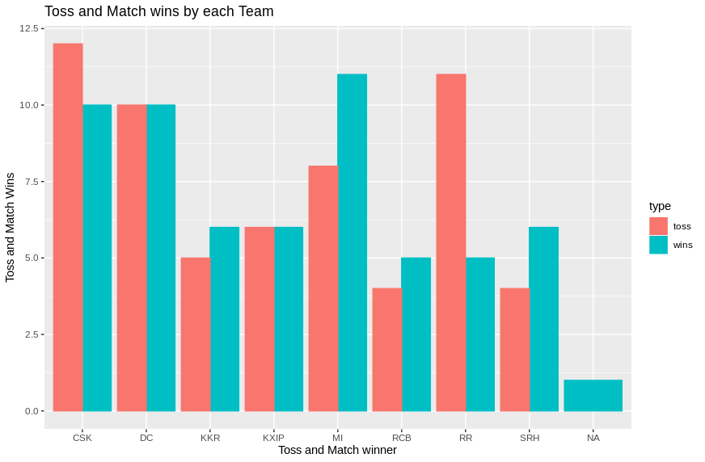

######################### city with most number of match ###################
venue_c <- data%>%
left_join(matches,by=c("match_id"="id"))%>%
select(match_id,city,total_runs,wickets)%>%
group_by(city)%>%
summarize(runs=sum(total_runs),wickets=sum(wickets,na.rm=TRUE))
city_mat <- matches %>%
group_by(city)%>%
summarize(matches=n())
venue_c <- venue_c %>%
left_join(city_mat, by=c("city"="city"))%>%
mutate(Avg_runs=runs/matches)%>%
mutate(Avg_wkt =wickets/matches)%>%
arrange(city)
venue_all <- venue_c%>%
left_join(venue_city, by=c("city"="city"))%>%
arrange(Avg_runs)
venue_all$city <- factor(venue_all$city, levels = venue_all$city[order(venue_all$matches)])
ggplot(venue_all,aes(x=city,y=matches,colour=city,fill=city))+
geom_bar(position = "dodge",stat = "identity")+
theme(legend.position="none")+ coord_flip()+
scale_y_continuous(name="Total no of Matches in each city")+
scale_x_discrete(name="Cities ")+
ggtitle("Cities with most no of matches")
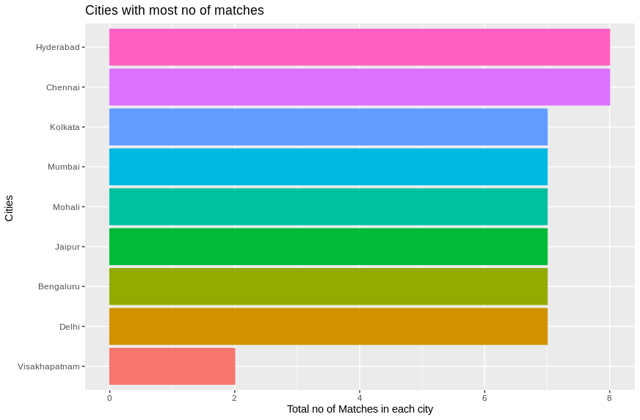

(We can see in the above plot that most of the maximum of 9 matches were played in Chennain and Hyderabad)

Analysis on Batsman of IPL 2019 by giving priorities to their performance measures

############### READIG FILE ###################################

most_runs <- read.csv("/home/dheeraj/Desktop/Lecture/6th_sem_Academics/DataScience/Lab2/batting_stats.csv")
head(most_runs)

############## Ordering According to Priority ################
a <- most_runs[order(-most_runs$RUNS),]
b <- a[order(-most_runs$AVG),]
c <- b[order(most_runs$INN),]
d <- c[order(-most_runs$SR),]
e <- d[order(-most_runs$X4S),]

(I gave priority in the following order by highest runs scored, maximum avg of the player, minimum innings played, highest Strike rate, maximum number of fours)

############# Player who topped the list ###################
select(head(e, n=1), PLAYER, RUNS)
####### Output > PLAYER
David Warner

########### Player who scored maximum runs #################
max_run <- e[which.max(e$RUNS),]
select(max_run, PLAYER)
####### Output > PLAYER
David Warner

########### Player who've highest Strike Rate ##############
max_sr <- e[which.max(e$SR),]
select(max_sr, PLAYER)
####### Output > PLAYER
Andre Russell

############# Player who hit highest 4rs ###################
max_fours <- e[which.max(e$X4S),]
select(max_fours, PLAYER)
####### Output > PLAYER
Shikhar Dhawan

############# Player who've highest Average ###################
max_avg <- e[which.max(e$AVG),]
select(max_avg, PLAYER)
####### Output > PLAYER
MS Dhoni

############# Player who hit highest Sixes ###################
max_sixes <- e[which.max(e$X6S),]
select(max_sixes, PLAYER)
####### Output > PLAYER
Andre Russell

############# Player who played minimum match ###############
min_match <- e[which.min(e$MATCHES),]
select(min_match, PLAYER)
####### Output > PLAYER
K Khaleel Ahmed

############# Top ten player’s name in my list ###################
select(head(e, n=10), PLAYER)
####### Output > PLAYER
1 David Warner
2 Lokesh Rahul
3 Shikhar Dhawan
4 Jonny Bairstow
5 Shreyas Iyer
6 Ajinkya Rahane
7 Quinton de Kock
8 Hardik Pandya
9 MS Dhoni
10 Shane Watson

########## Top ten player's with their data in my list ###########
select(head(e, n=10), PLAYER,INN, RUNS, AVG, SR ,X4S, X6S )
####### Output > PLAYER INN RUNS AVG SR X4S X6S
1 David Warner 12 692 69.20 143.87 57 21
2 Lokesh Rahul 14 593 53.91 135.39 49 25
3 Shikhar Dhawan 16 521 34.73 135.68 64 11
4 Jonny Bairstow 10 445 55.62 157.24 48 18
5 Shreyas Iyer 16 463 30.87 119.95 41 14
6 Ajinkya Rahane 13 393 32.75 137.89 45 9
7 Quinton de Kock 16 529 35.27 132.91 45 25
8 Hardik Pandya 15 402 44.67 191.43 28 29
9 MS Dhoni 12 416 83.20 134.63 22 23
10 Shane Watson 17 398 23.41 127.56 42 20

Analysis on Bowlers of IPL 2019 by giving priorities to their performance measures

############### READIG FILE ###################################

bowling_stats <- read.csv("/home/dheeraj/Desktop/Lecture/6th_sem_Academics/DataScience/Lab2/bowling_stats.csv")
head(bowling_stats)

############## Ordering According to Priority ################
a <- bowling_stats[order(-bowling_stats$WKTS),]
b <- a[order(bowling_stats$BALLS),]
c <- b[order(bowling_stats$MATCHES),]
e <- c[order(-bowling_stats$RUNS),]

(Priority given in the following order by maximum wickets taken, minimum balls throw by him , minimum match played, and runs given by him)

############# Player who topped the list ###################
select(head(e, n=1), PLAYER)
####### Output > PLAYER
Imran Tahir

########### Player who taken maximum wicket ################
max_wkt <- e[which.max(e$WKTS),]
select(max_wkt, PLAYER)
####### Output > PLAYER
Imran Tahir

########### Player who've thrown maximum balls ##############
max_run <- e[which.max(e$BALLS),]
select(max_run, PLAYER)
####### Output > PLAYER

Deepak Chahar

############# Player who gave minimum runs ##################
max_run <- e[which.min(e$RUNS),]
select(max_run, PLAYER)
####### Output > PLAYER
Amit Mishra

############# Player who played minimum match ###############
max_run <- e[which.min(e$MATCHES),]
select(max_run, PLAYER)
####### Output > PLAYER
K Khaleel Ahmed

############# Top ten player's name in my list ###################
select(head(e, n=10), PLAYER)
####### Output > PLAYER
1 Imran Tahir
2 Axar Patel
3 K Khaleel Ahmed
4 Mohammed Shami
5 Amit Mishra
6 Navdeep Saini
7 Ishant Sharma
8 Shreyas Gopal
9 Sam Curran
10 Kagiso Rabada

########## Top ten player's with their data in my list ###########
select(head(e, n=10), PLAYER, MATCHES, BALLS, RUNS, WKTS )
####### Output > PLAYER MATCHES BALLS RUNS WKTS
1 Imran Tahir 17 386 431 26
2 Axar Patel 14 306 364 10
3 K Khaleel Ahmed 9 209 287 19
4 Mohammed Shami 14 324 469 19
5 Amit Mishra 11 240 270 11
6 Navdeep Saini 13 288 397 11
7 Ishant Sharma 13 276 349 13
8 Shreyas Gopal 14 288 347 20
9 Sam Curran 9 198 323 10
10 Kagiso Rabada 12 282 368 25

Analysis of 10 Players and their 10 match individual scores finding median, consistency, corelation between few pairs of Players

######## loading data of top 10 players and their individual 10 match score ######
ind_ply <- read.csv("/home/dheeraj/Desktop/Lecture/6th_sem_Academics/DataScience/Lab2/player_eachmatch.csv")
View(ind_ply)
median(ind_ply$DavidWarner)
####### Output > [1] 54

median(ind_ply$LokeshRahul)
####### Output > [1] 33.5

median(ind_ply$ShikharDhawan)
####### Output > [1] 32.5

median(ind_ply$JonnyBairstow)
####### Output > [1] 43

median(ind_ply$ShreyasIyer)
####### Output > [1] 35.5

median(ind_ply$AjinkyaRahane)
####### Output > [1] 20

median(ind_ply$QuintondeKock )
####### Output > [1] 31

median(ind_ply$HardikPandya)
####### Output > [1] 26.5

median(ind_ply$MSDhoni)
####### Output > [1] 37

median(ind_ply$ShaneWatson )
####### Output > [1] 9.5

Below is consitency of each players (player which have values near to 0 are more consistent and which’re near to 1 are inconsistent)

######### Finding Coefficient of variance ###########
sd(ind_ply$LokeshRahul)/mean(ind_ply$DavidWarner)
####### Output > [1] 0.6536159

sd(ind_ply$LokeshRahul)/mean(ind_ply$LokeshRahul)
####### Output > [1] 0.9039726

sd(ind_ply$ShikharDhawan)/mean(ind_ply$ShikharDhawan)
####### Output > [1] 0.8334738

sd(ind_ply$JonnyBairstow)/mean(ind_ply$JonnyBairstow)
####### Output > [1] 0.7892764

sd(ind_ply$ShreyasIyer)/mean(ind_ply$ShreyasIyer)
####### Output > [1] 0.66783

sd(ind_ply$AjinkyaRahane)/mean(ind_ply$AjinkyaRahane)
####### Output > [1] 1.052911

sd(ind_ply$QuintondeKock )/mean(ind_ply$QuintondeKock )
####### Output > [1] 0.6318267

sd(ind_ply$HardikPandya)/mean(ind_ply$HardikPandya)
####### Output > [1] 0.4513528

sd(ind_ply$MSDhoni)/mean(ind_ply$MSDhoni)
####### Output > [1] 0.6289972

sd(ind_ply$ShaneWatson )/mean(ind_ply$ShaneWatson )
####### Output > [1] 1.002898

Box plots for each 10 players We can see median from the plot at mid line is median

############### PLOT 1: Box plot for David Warner ###############
boxplot(ind_ply$DavidWarner)
num = as.numeric(ind_ply$DavidWarner)
outvalues = boxplot(num)$out
which(ind_ply$DavidWarner %in% outvalues)
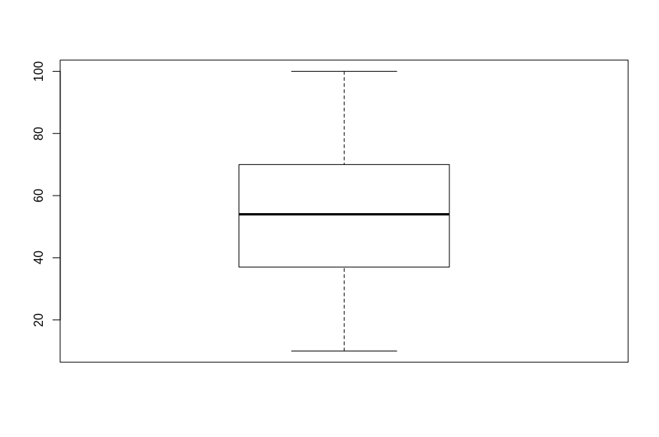

############### PLOT 2: Box plot for LokeshRahul ###############
boxplot(ind_ply$LokeshRahul)
num = as.numeric(ind_ply$LokeshRahul)
outvalues = boxplot(num)$out
which(ind_ply$LokeshRahul %in% outvalues)
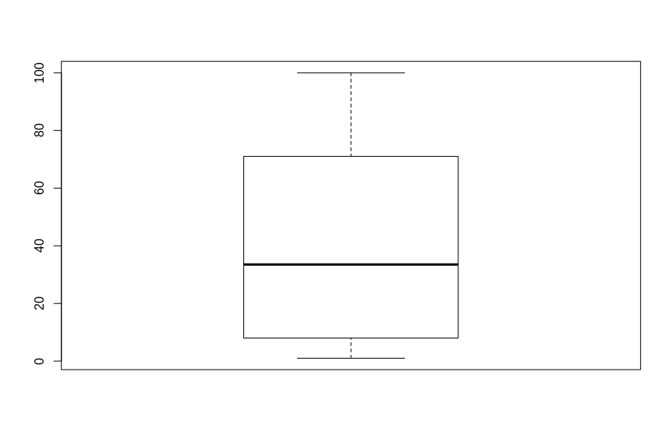

############### PLOT 3: Box plot for ShikharDhawan ###############
boxplot(ind_ply$ShikharDhawan)
num = as.numeric(ind_ply$ShikharDhawan)
outvalues = boxplot(num)$out
which(ind_ply$ShikharDhawan %in% outvalues)
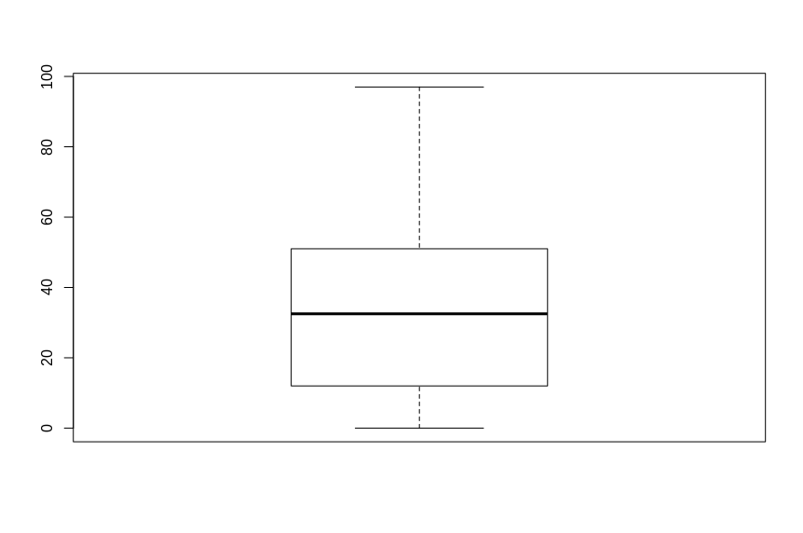
############### PLOT 4: Box plot for JonnyBairstow ###############
boxplot(ind_ply$JonnyBairstow)
num = as.numeric(ind_ply$JonnyBairstow)
outvalues = boxplot(num)$out
which(ind_ply$JonnyBairstow %in% outvalues)
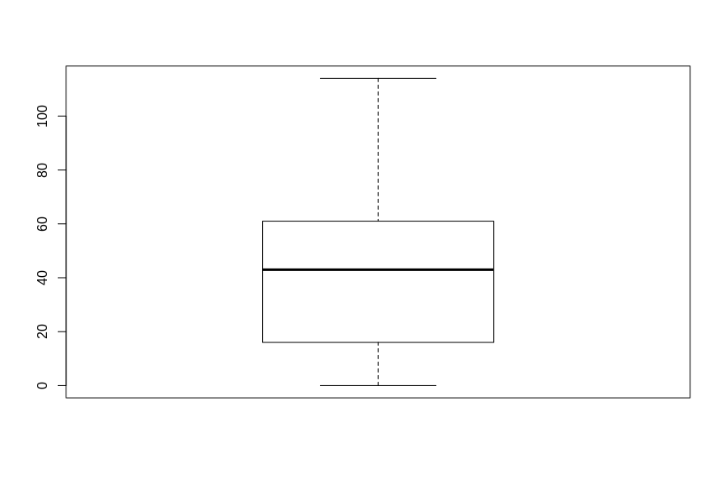

############### PLOT 5: Box plot for ShreyasIyer ###############
boxplot(ind_ply$ShreyasIyer)
num = as.numeric(ind_ply$ShreyasIyer)
outvalues = boxplot(num)$out
which(ind_ply$ShreyasIyer %in% outvalues)
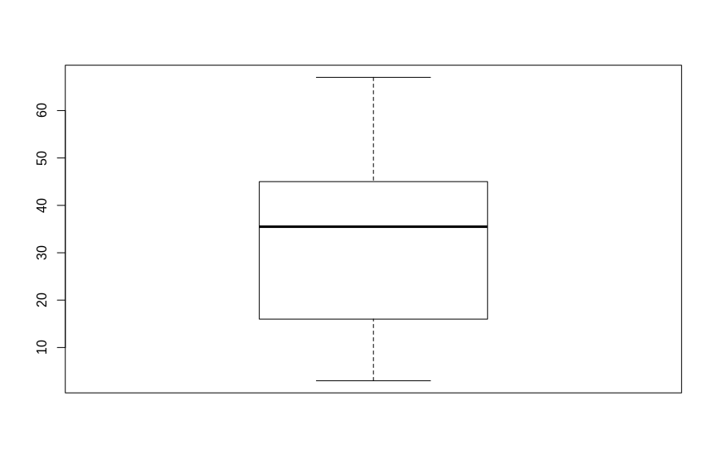
############### PLOT 6: Box plot for AjinkyaRahane ###############
boxplot(ind_ply$AjinkyaRahane)
num = as.numeric(ind_ply$AjinkyaRahane)
outvalues = boxplot(num)$out
which(ind_ply$AjinkyaRahane %in% outvalues) (We can see an Outliar here i.e, at score 2)
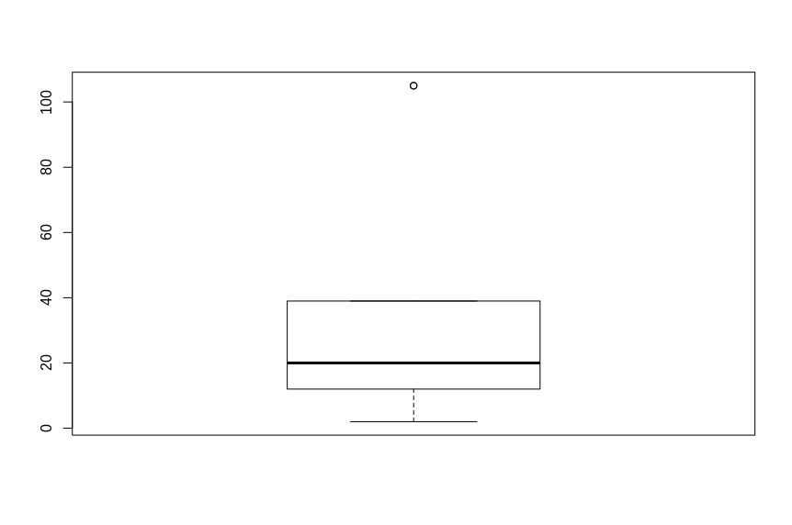

############### PLOT 7: Box plot for QuintondeKock ###############
boxplot(ind_ply$QuintondeKock)
num = as.numeric(ind_ply$QuintondeKock)
outvalues = boxplot(num)$out
which(ind_ply$QuintondeKock %in% outvalues)
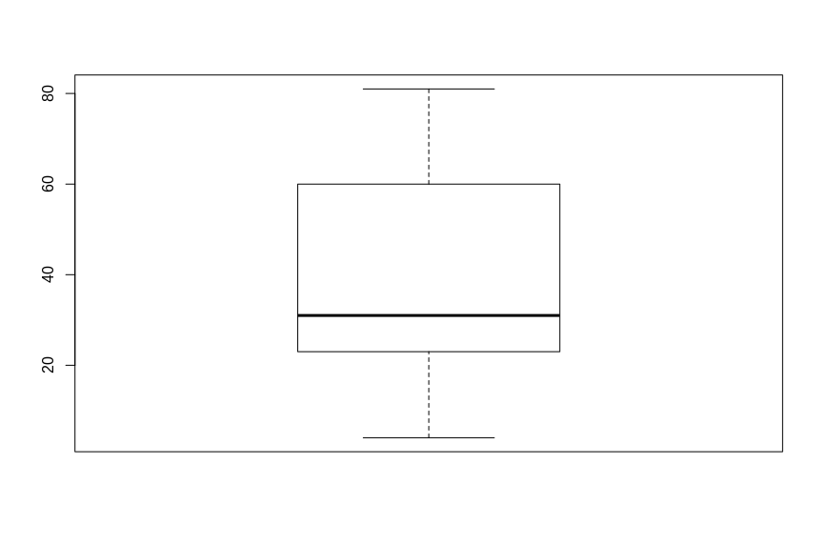

############### PLOT 8: Box plot for HardikPandya ###############
boxplot(ind_ply$HardikPandya)
num = as.numeric(ind_ply$HardikPandya)
outvalues = boxplot(num)$out
which(ind_ply$HardikPandya %in% outvalues)
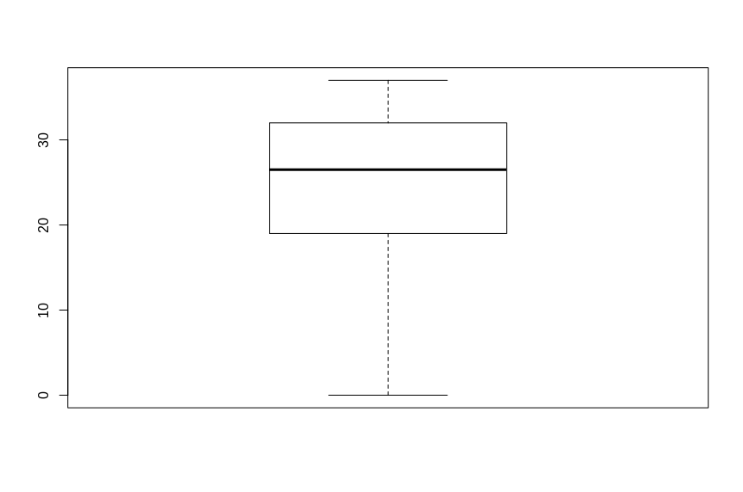

############### PLOT 9: Box plot for MSDhoni ################
boxplot(ind_ply$MSDhoni)
num = as.numeric(ind_ply$MSDhoni)
outvalues = boxplot(num)$out
which(ind_ply$MSDhoni %in% outvalues)
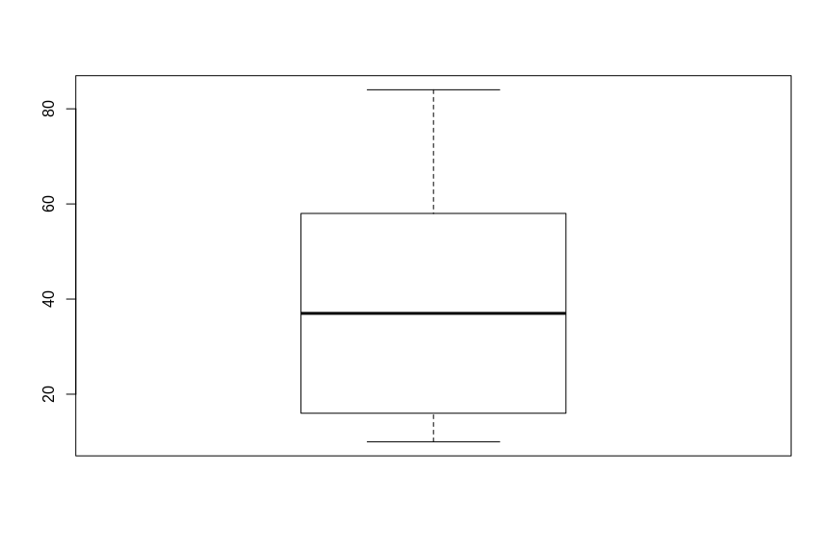

############### PLOT 10: Box plot for ShaneWatson ################
boxplot(ind_ply$ShaneWatson)
num = as.numeric(ind_ply$ShaneWatson)
outvalues = boxplot(num)$out
which(ind_ply$ShaneWatson %in% outvalues)
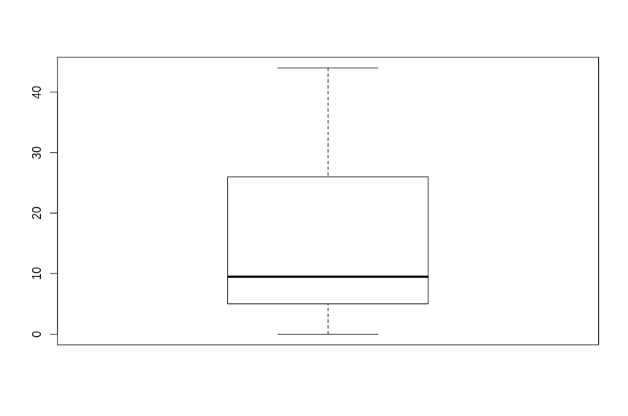

Correlation between two few pairs of players

######## corelation between Davidwarner and Lokesh rahul ############
cor.test(ind_ply$DavidWarner, ind_ply$LokeshRahul, method = "spearman")
####### Output > Spearman's rank correlation rho

data: ind_ply$DavidWarner and ind_ply$LokeshRahul
S = 150.96, p-value = 0.8152
alternative hypothesis: true rho is not equal to 0
sample estimates:
rho
0.08510678

######## corelation between ShikharDhawan and JonnyBairstow ############
cor.test(ind_ply$ShikharDhawan, ind_ply$JonnyBairstow, method = "spearman")
####### Output > Spearman's rank correlation rho

data: ind_ply$ShikharDhawan and ind_ply$JonnyBairstow
S = 188, p-value = 0.7072
alternative hypothesis: true rho is not equal to 0
sample estimates:
rho
-0.1393939

######## corelation between ShreyasIyer and AjinkyaRahane ############
cor.test(ind_ply$ShreyasIyer, ind_ply$AjinkyaRahane, method = "spearman")
####### Output > Spearman's rank correlation rho

data: ind_ply$ShreyasIyer and ind_ply$AjinkyaRahane
S = 248.52, p-value = 0.1355
alternative hypothesis: true rho is not equal to 0
sample estimates:
rho
-0.5062114

######## corelation between QuintondeKock and HardikPandya ############
cor.test(ind_ply$QuintondeKock, ind_ply$HardikPandya, method = "spearman")
####### Output > Spearman's rank correlation rho

data: ind_ply$QuintondeKock and ind_ply$HardikPandya
S = 120.87, p-value = 0.455
alternative hypothesis: true rho is not equal to 0
sample estimates:
rho
0.2674784

######## corelation between MSDhoni warner and ShaneWatson ############
cor.test(ind_ply$MSDhoni, ind_ply$ShaneWatson, method = "spearman")
####### Output > Spearman's rank correlation rho
data: ind_ply$MSDhoni and ind_ply$ShaneWatson
S = 189.22, p-value = 0.6857
alternative hypothesis: true rho is not equal to 0
sample estimates:
rho
-0.1467897

